Title of the Invention: Ai CCTV Footage Detection
Inventor Details:
S. No. | Name with Affiliation | Nationality | Address |  |  | Email/ Contact Number | Signature
S. No. | Name with Affiliation | Nationality | Full Address | District & Pin code | State & County | Email/ Contact Number | Signature
1 | Dr. Husna Khouser G  Assistant Professor | INDIAN | Dept of ECE,  SNS College of Technology, | Coimbatore - 641035 | Tamilnadu, India | husnaece17@gmail.com  6380232559
2 | AJUVAITHA K | INDIAN | Dept of CSE(IOT),  SNS College of Technology, | Coimbatore - 641035 | Tamilnadu, India | ajuvaitha.k.iot.2023@snsce.ac.in  7373787243 | 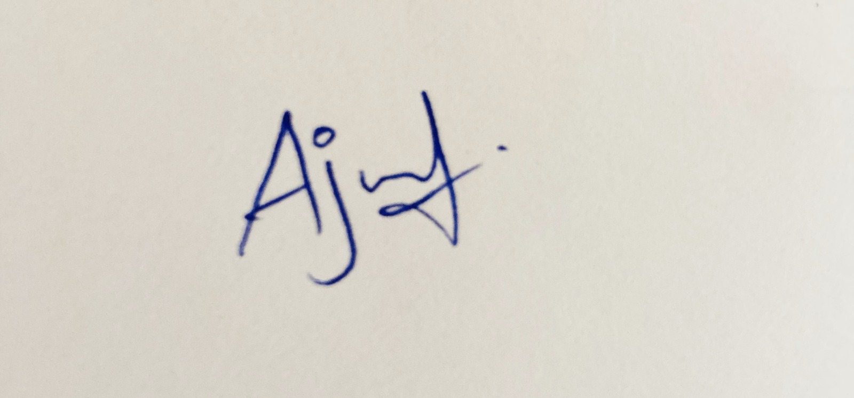
3 | KANTHIMATHINATHAN P | INDIAN | Dept of CSE(IOT),  SNS College of Technology, | Coimbatore - 641035 | Tamilnadu, India | kanthimathinathan.p.iot.2023@snsce.ac.in  6383349601 | 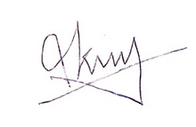
4 | POORNA DEVI M | INDIAN | Dept of CSE(IOT),  SNS College of Technology, | Coimbatore - 641035 | Tamilnadu, India | poornadevi.m.iot.2023@snsce.ac.in  9342568524 | 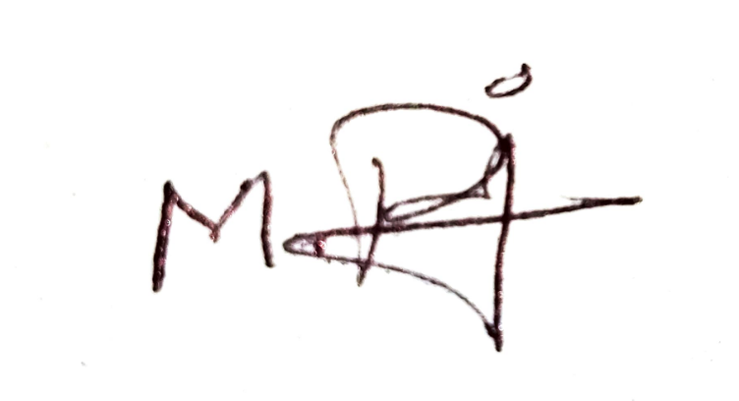
5 | Dr.M.Siva Ramkumar  Associate Professor | INDIAN | Dept of ECE,  SNS College of Technology, | Coimbatore - 641035 | Tamilnadu, India | sivaram0699@gmail.com  9629573042 | 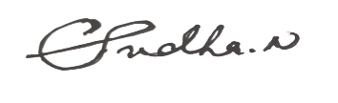
6 | Mrs.B.Sajitha  Assistant Professor | INDIAN | Dept of ECE,  SNS College of Technology, | Coimbatore - 641035 | Tamilnadu, India | sajitha.mpb@gmail.com  94884 58018

Inventors: (A) Same as applicants: No (B) Different than the applicants: Yes

